8. PO/Requisition Menu: R. Reports Menu: 2. Received Goods Report

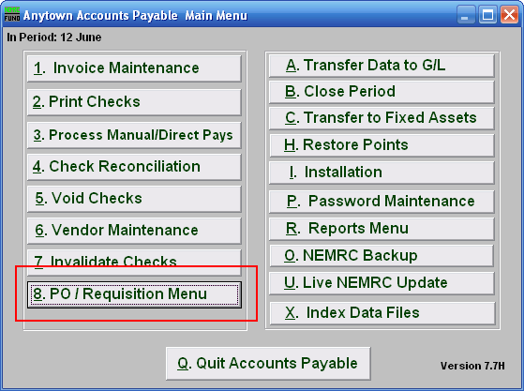
Click on “8. PO / Requisition Menu” from the Main Menu and the following window will appear:

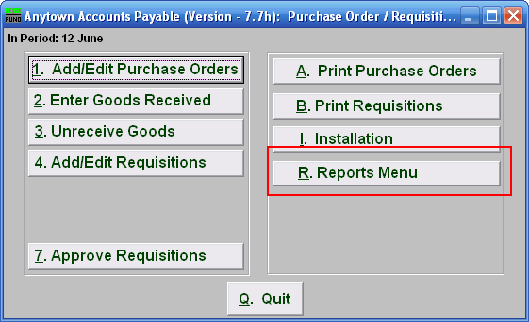
Click on “R. Reports Menu” from the Purchase Order / Requisition Menu and the following window will appear:

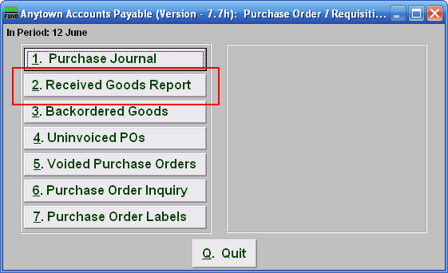
Click on “2. Received Goods Report” from the Main Menu and the following window will appear:

Received Goods Report

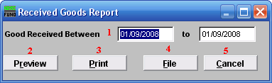
- Good Received Between: Enter the date you wish to have the report include.

- Preview: Click this button to preview this report. Refer to GENERAL PREVIEW for more information.

- Print: Click this button to print this report. Refer to GENERAL PRINTING for more information.

- File: Click this button to save this report on this computer. Refer to GENERAL FILE for more information.

- Cancel: Click “Cancel” to cancel and return to the previous screen.

